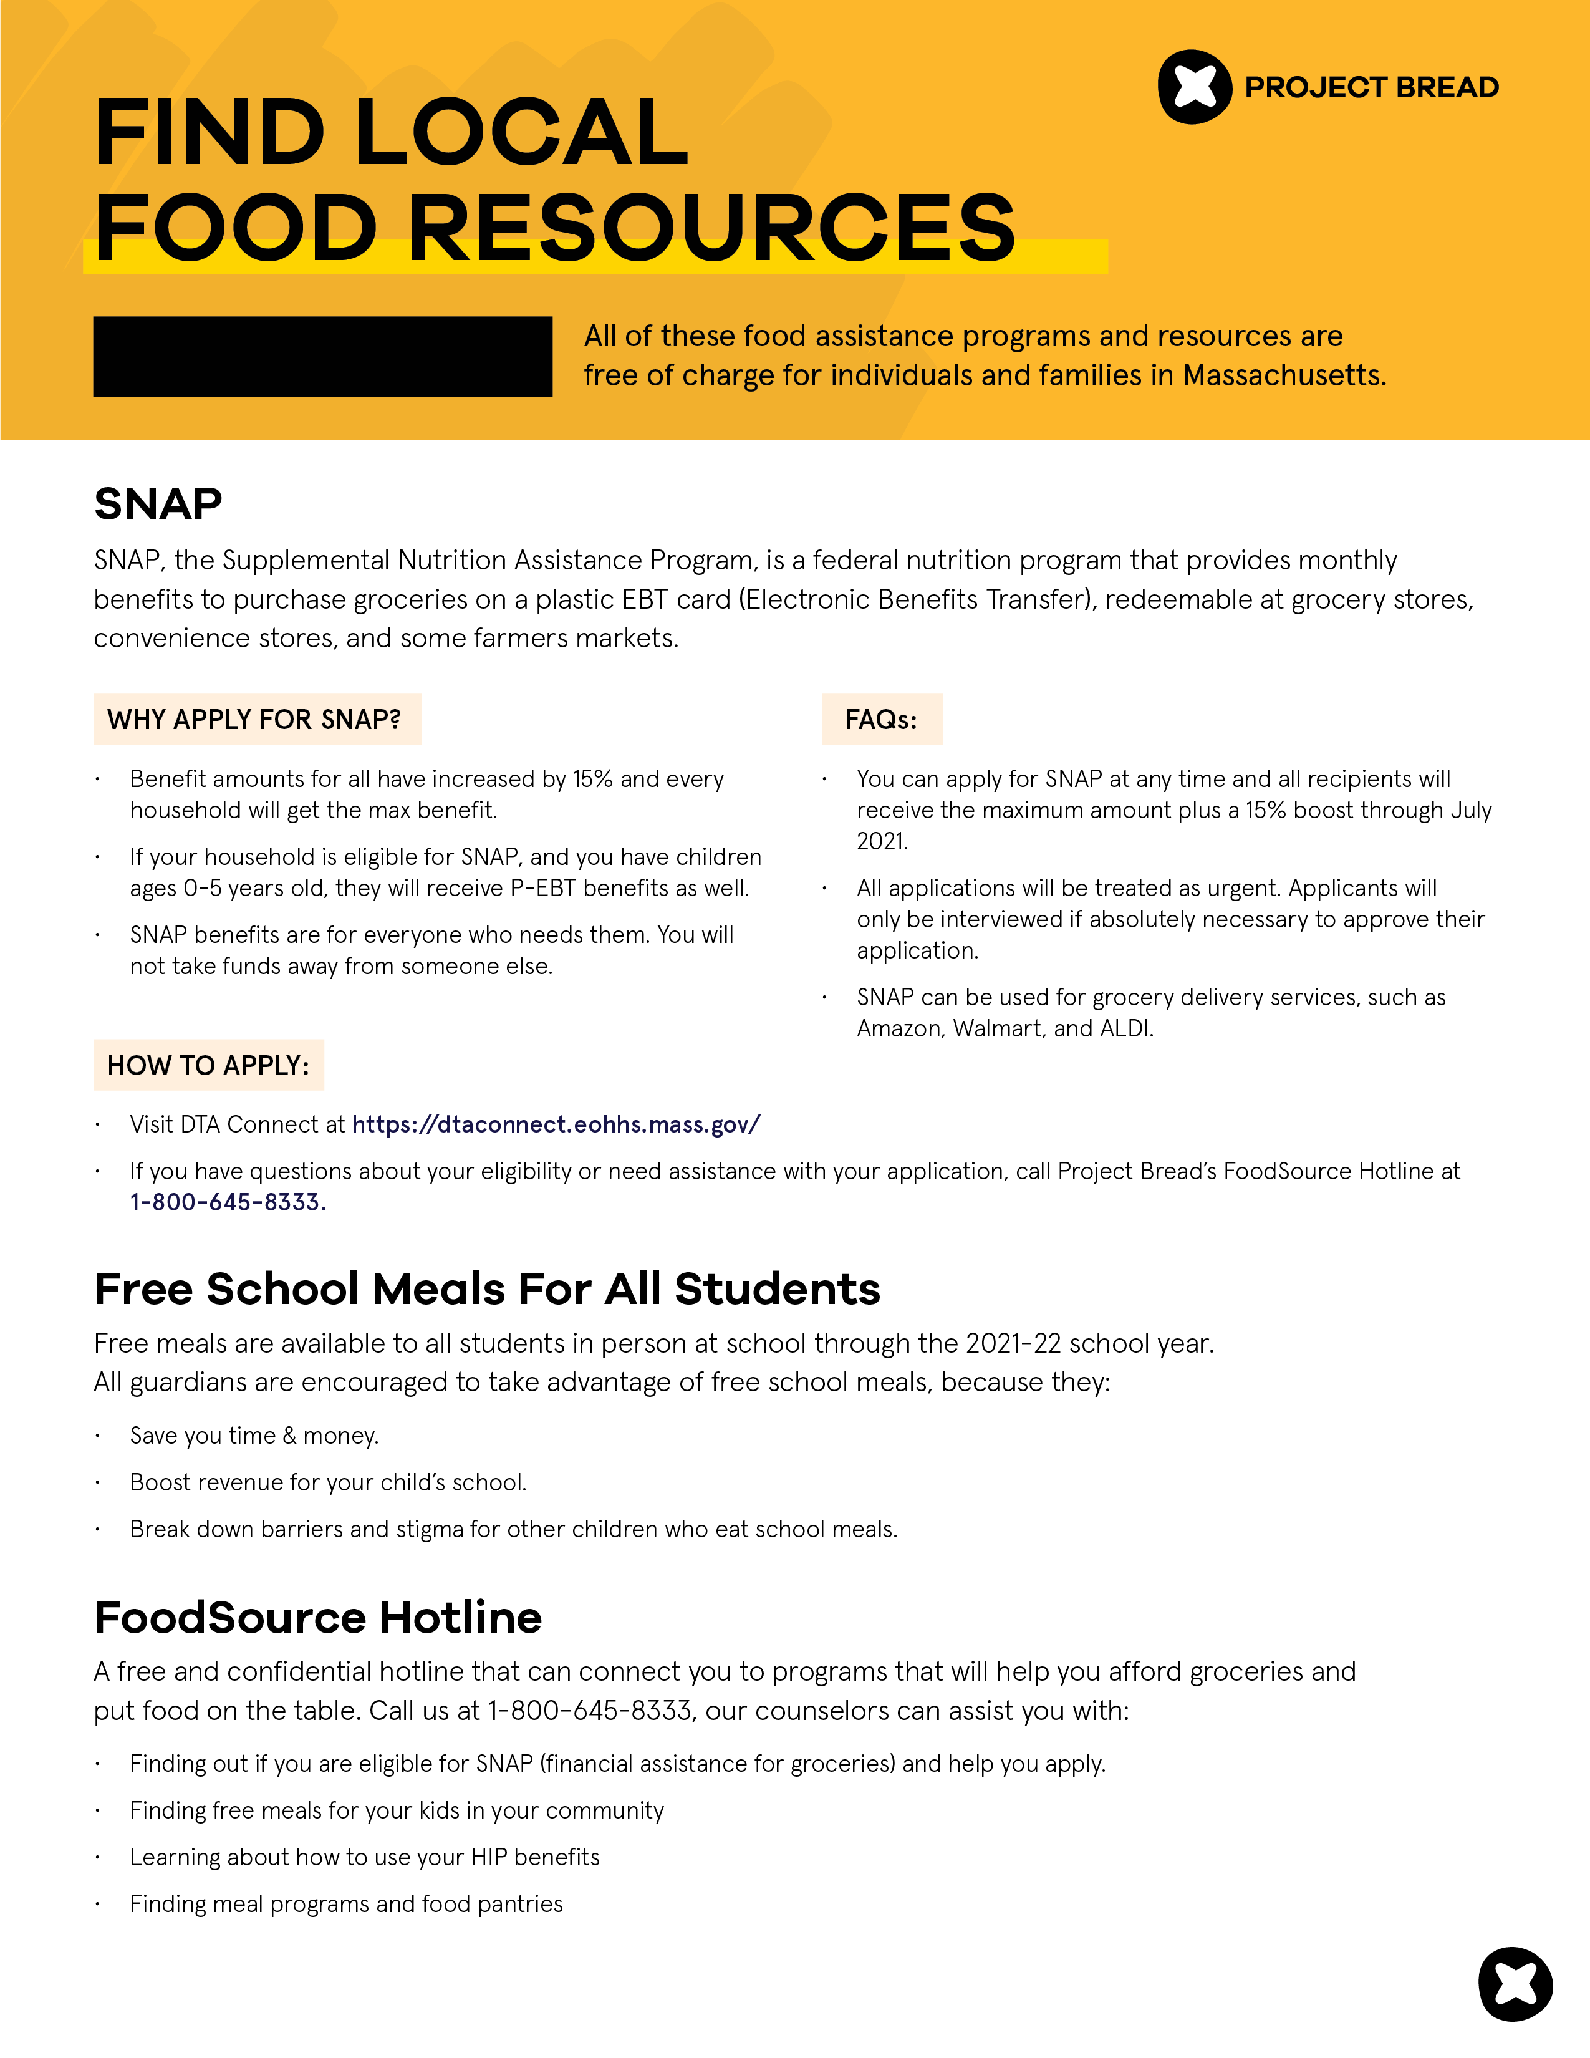



[DISTRICT NAME]

[Add local pantry information here]

[Add resource information here]

**[ENTER DISTRICT NAME]**