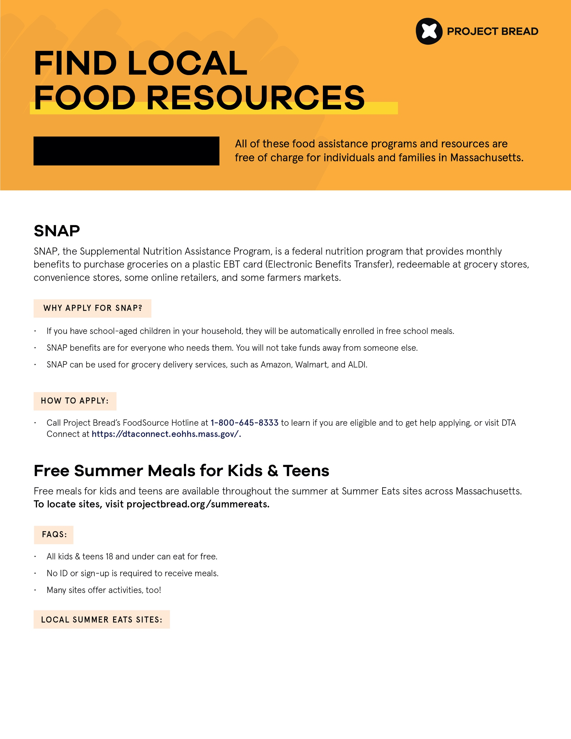

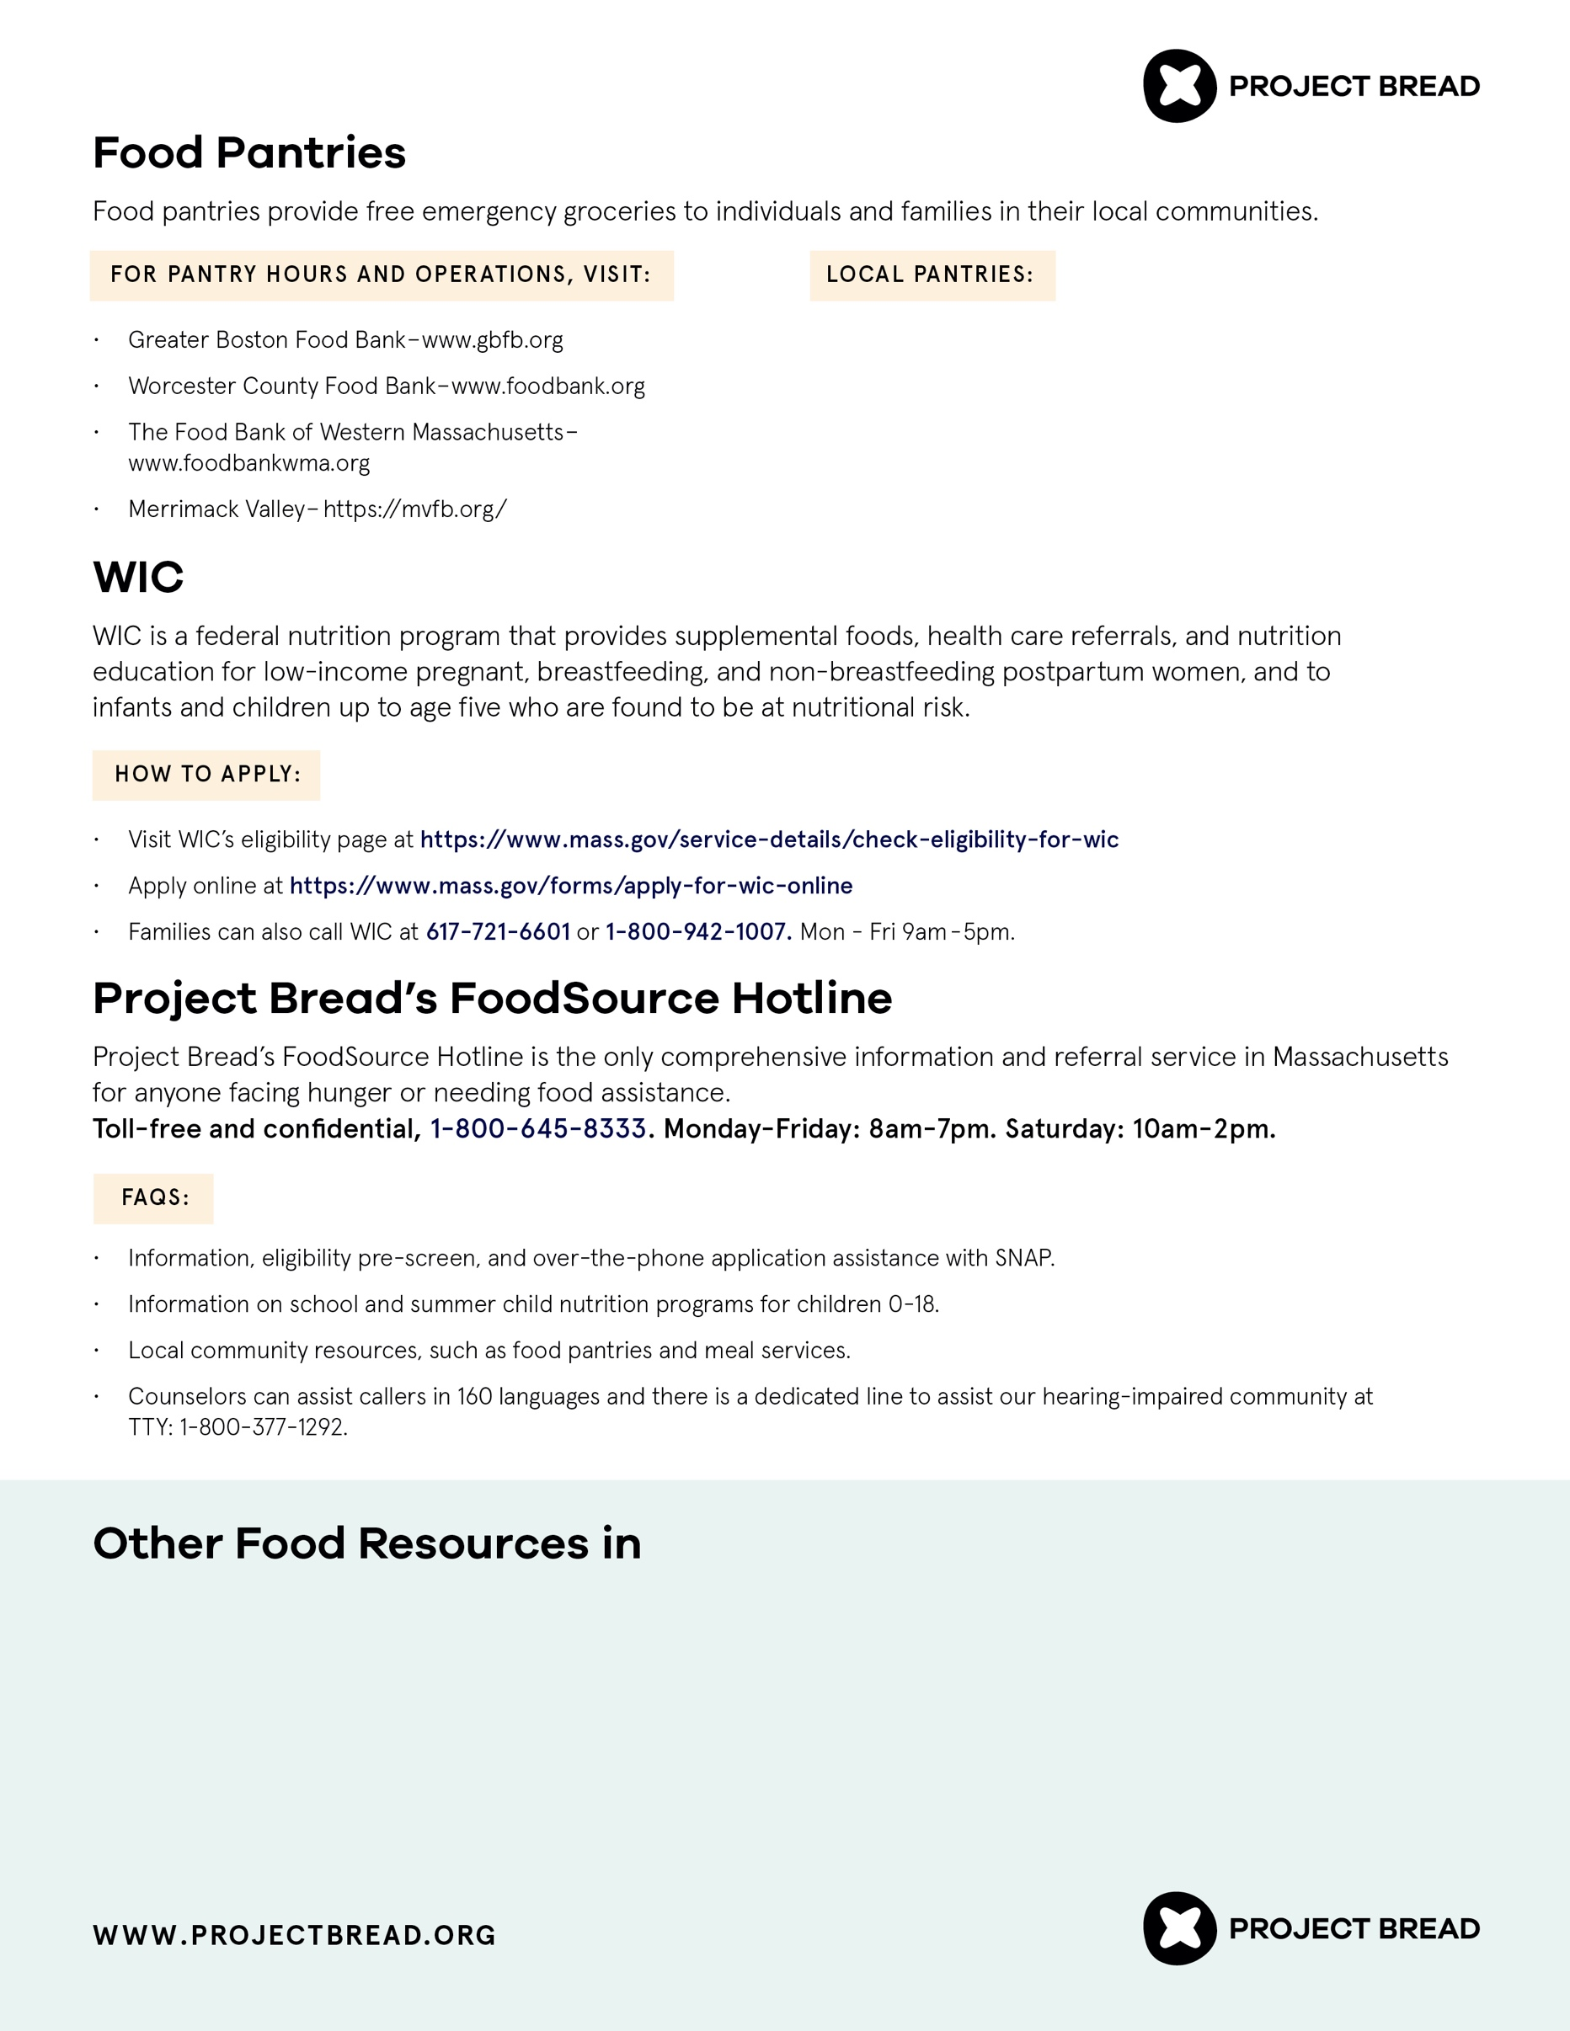

[Add meal site information here]

[DISTRICT NAME]

**[ENTER DISTRICT NAME]**

[Add local pantry information here]

[Add resource information here]